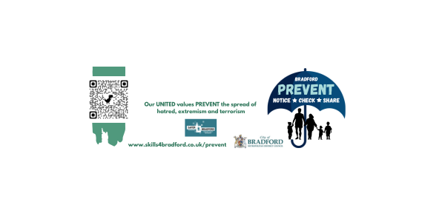

**July 2025**

Dear Parents and Carers,

As the summer holidays approach and children begin to spend more time at home, many will naturally turn to the online world for entertainment, learning, and social interaction. While the internet offers a wealth of opportunities, it also presents certain risks—particularly for young and impressionable minds.

Within Bradford Local Authority, the Prevent team works closely with schools and the wider community to support understanding and implementation of the Prevent Duty. Today, we are reaching out to raise awareness not only about the online risks associated with the Prevent agenda, but also to highlight broader concerns around online safety.

More young people than ever are engaging with digital platforms, and while these spaces can be both fun and educational, they can also expose children to harmful content or individuals. Just as we teach children about “stranger danger” in the real world, it is equally important to equip them with the knowledge and tools to stay safe online.

**Key Online Safety Tips for Parents and Carers:**

* Talk regularly with your child about their online activity. Encourage open conversations about what they’re doing, who they’re talking to, and how they feel about their experiences.
* Set clear boundaries around screen time and the types of websites or apps they can use.
* Use parental controls on devices, apps, and your home internet to help filter inappropriate content and monitor usage.
* Encourage critical thinking—help your child understand that not everything they see or read online is true or safe.
* Be alert to signs of distress or secrecy around online activity, which could indicate exposure to harmful content or online grooming.
* Stay informed about the latest apps, games, and trends that children are using, as these can change rapidly.

We encourage you to take a moment to explore the resources available on our dedicated webpage. These materials offer practical guidance and support to help you keep your children safe while they navigate the digital world.

**Link:** [**Resources for Parents and Carers | Skills 4 Bradford**](https://www.skills4bradford.co.uk/Page/28876)

With best wishes,

The Prevent Team